AWS Deployment Documentation
Edge-Driven Federated System for UPI Fraud Detection
Date: November 19, 2025

1. Introduction
1.1 Project Overview
This document describes the deployment of a federated learning system for UPI fraud detection on AWS EC2 infrastructure. The system uses distributed machine learning to train models across multiple edge nodes while preserving data privacy.
1.2 System Architecture
The deployment consists of three main components:
Central Server: Coordinates federated learning and aggregates model updates
Edge Clients (2): Train local models on distributed datasets
Architecture Diagram:
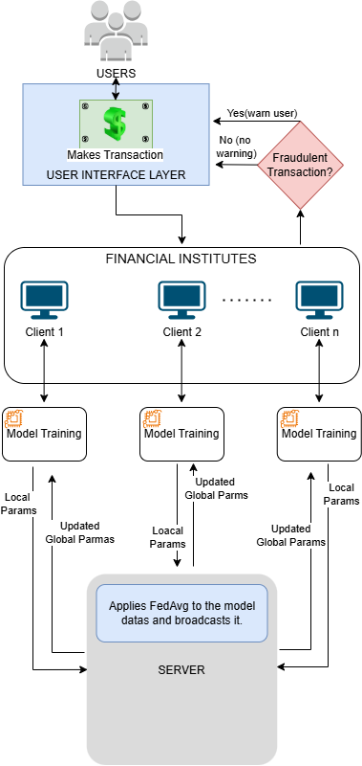
2. AWS Infrastructure Setup
2.1 EC2 Instance Configuration
Instance Specifications:
Parameter | Value
AMI | Ubuntu 24.04 LTS
Instance Type | T3.micro
vCPUs | 2
RAM | 2 GB
Storage | 8 GB EBS
Number of Instances | 3 (1 server + 2 clients)

2.2 Security Group Configuration
Inbound Rules:

SERVER:
Type | Port | Source
SSH | 22 | 0.0.0.0/0
Custom TCP | 5000 | 0.0.0.0/0
CLIENT:
Type | Port | Source
SSH | 22 | 0.0.0.0/0

3. Installation and Configuration
Step 1: Connect to EC2 Instance
- ssh -i key.pem ubuntu@<ip> or in aws UI, select instance running and click connect.
Step 2: Install Dependencies
- sudo apt-get install git -y
- sudo apt update
- sudo apt install -y python3 python3-pip

Step 3: Setup Virtual Environment
- sudo apt install -y python3-venv
- python3 -m venv venv
- source venv/bin/activate
- pip install --upgrade pip

- Server: pip install flask numpy pandas scikit-learn tensorflow
- Client: pip install numpy pandas scikit-learn imbalanced-learn tensorflow requests
Step 4: Clone Repository
- git clone https://github.com/Zkiel013/Edge-Driven-Federated-System-for-UPI-Fraud-Detection
- cd Edge-Driven-Federated-System-for-UPI-Fraud-Detection
Step 5: UPDATE THE SERVER_URL IN CLIENTS
- Update: SERVER_URL = <Public IP address of the server instance>

4. System Execution
4.1 Running the Server
- On server instance run the cmd:
- cd server
- python3 server.py

4.2 Running Client Nodes
On client instance run the cmd:
- cd client
Client 1 (separate ssh console):
- Python3 client1.py
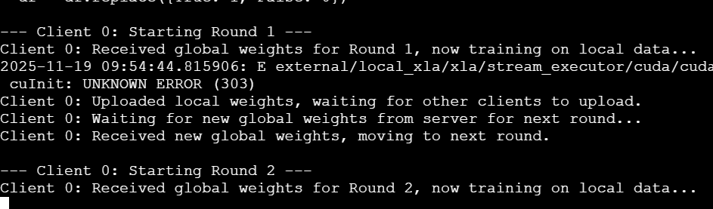

Client 2 (separate ssh console):
- Python3 client2.py
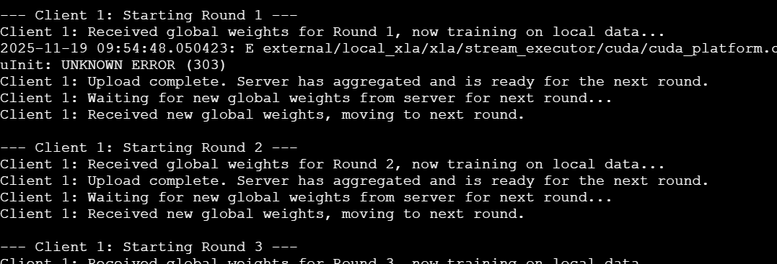
4.3 Training Process
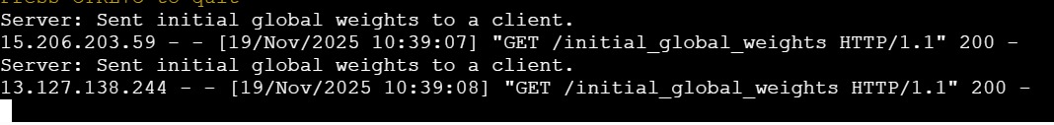
- Client fetches initial global weights

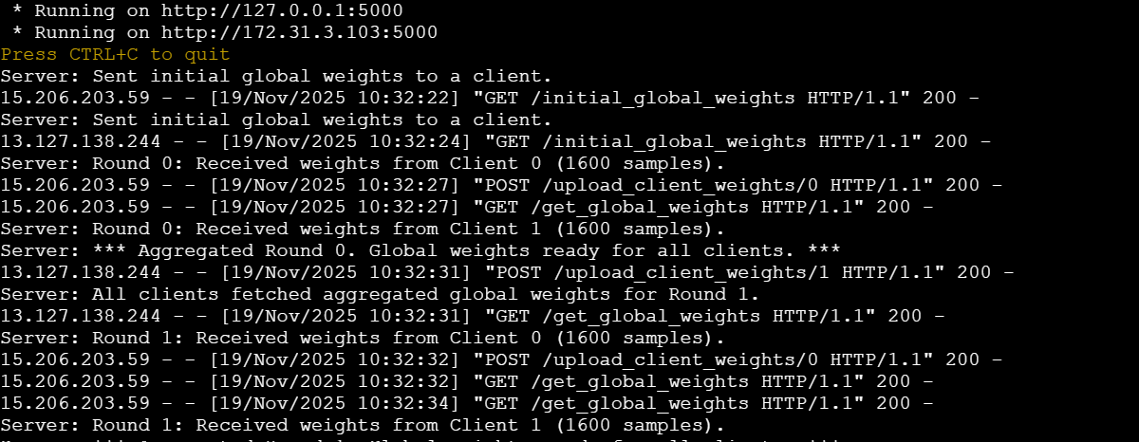
- The server performs weight aggregation at the end of each round.

5. Results and Performance
5.1 Dataset Information
Metric | Value
Total transactions | 10,000
Fraudulent (class 1) | 150 (1.5%)
Legitimate (class 0) | 9850(98.5%)
Features | 52
Training data per client | 10,000
Test data | 10,000

5.2 Model Performance
- Final model metrics after 5 federated rounds:
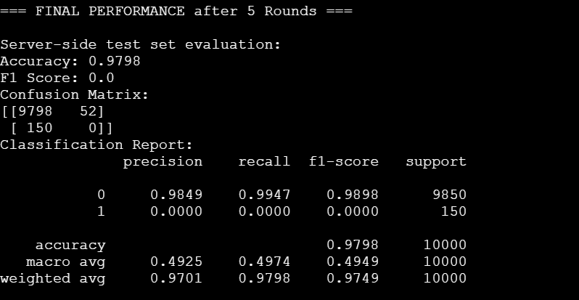
Metric | Value (weighted avg)
Accuracy | 97.98%
Precision | 97.01%
Recall | 97.98%
F1-Score | 97.49%
Training Time | 5 minutes
Communication Rounds | ~5

7. Conclusion
Summary
Successfully deployed an edge-driven federated learning system on AWS EC2.

